**Correlation of Brixia Score changes with length of stay in patient with COVID-19**

Verawati Sutedjo,a Widiastuti Soewondo,b Dini Rachma Erawatic

aDepartment of Radiology of Sumber Waras Hospital, Jl. Kyai Tapa no.1, Jakarta Barat, DKI Jakarta, Indonesia

bDepartment of Radiology, Faculty of Medicine Universitas Sebelas Maret, Jl. Kol Sutarto No.132, Jebres, Surakarta, Indonesia

cDepartment of Radiology, Faculty of Medicine Universitas Brawijaya, Jl. Veteran, Ketawanggede, Kota Malang, Jawa Timur, Indonesia

Corresponding author: Widiastuti Soewondo. Faculty of Medicine Universitas Sebelas Maret, Jl. Kol Sutarto No.132, Jebres, Surakarta, Indonesia. Email: widiastuti.sprad56@staff.uns.ac.id

Declaration of interest : None.

**Abstract**

The increase number of Covid-19 hospitalization cases is often unexpected. Lungs are an important organ involved in Covid-19, and the degree of lung damage largely determines the severity of the disease. A basic radiological initial examination of a serial chest X-ray can be used to assess changes in pulmonary parenchymal damage by the Brixia score parameter. Brixia's score is still likely to be used to estimate the length of treatment of Covid-19 patients. This retrospective research was conducted at Sumber Waras Hospital in the period November 2021 until January 2022. Consequetive sampling of patients who were confirmed Covid-19 who and treated at Sumber Waras hospital. Brixia's score assessment on the initial and serial chest X-ray, then divided into 4 categories: low to low, low to high, high to low, and high to high. Median differences in the length of treatment in various categories of brixia score changes were analyzed by the Kruskal-Wallis method followed by Mann-Whitney U. 190 subjects were found to be able to participate in this study with an age range of 18 years to 87 years. The non-parametric analysis used the Mann Whitney U-test independent test for each Brixia score category associated with length of treatment. The median score of Brixia at the beginning of treatment is 4 (range 0 - 18), and the median score of Brixia on serial examination is 6 (range 0 - 18). Based on changes in Brixia's scores, there were 109 patients (57.4%) in the low to treatment was 10 days in patients with low to low Brixia scores, 11 days on low to high Brixia scores, 11 days in high to low Brixia scores, and 8 days on high to high Brixia scores. The median difference is not statistically meaningful (p = 0.377).

**Introduction**

Severe Acute Respiratory Syndrome Coronavirus 2 (SARS-CoV-2) is a new virus transmitted from human to human, first discovered in Wuhan, Hubei province in December 2019.1 The World Health Organization announced a pandemic period in March 2020.2 The SARS-COV2 virus is transmitted mainly through droplets and in some conditions it can be transmitted through aerosols or indirect contact with the surface of contaminated objects.3 Covid-19 patients with symptoms moderate, severe, or critical requires hospitalization. One of the parameters of assessing the quality and efficiency of treatment of Covid-19 patients is the length of treatment. It is suspected that the assessment of Brixia scores through thoracic X-ray can predict the length of treatment of COVID-19 patients.4,5 The Brixia score is one of the popular and widely used scores in a number of hospitals in the world because it is considered easy and systematic.6 Brixia score assessment is carried out by dividing the pulmonary field from the top to the base of the lung into three parts, namely the right A-B-C and the left D-E-F. Where the classification of abnormality findings in the pulmonary parenchyma is divided into 4 categories, namely normal pulmonary parenchyma has a score of 0, changes in instestitium tissue have a score of 1, changes in dominant interstitium tissue and changes in pulmonary alveoli have a score of 2, and the last if changes in alveoli are more dominant than changes in interstitium tissue have a score of 3. Brixia's total score is 18, a high score if a score greater is equal to 9 and a low score with a score value of less than 9.7

**Method**

The retrospective research was conducted at Sumber Waras Hospital in the period November 2021 until January 2022. Consequetive sampling of patients who were confirmed with Covid-and treated at Sumber Waras hospital. Brixia's score assessment on the initial and serial chest X-ray, then divided into 4 categories: low to low, low to high, high to low, and high to high. Median differences in the length of treatment in various categories of brixia score changes were analyzed by the Kruskal-Wallis method followed by Mann-Whitney U. 190 subjects were found to be able to participate in this study with an age range of 18 years to 87 years. Non-parametric analysis used the Mann Whitney U-test independent test for each Brixia score category associated with length of treatment.

**Result**

Table 1. Characteristic of subjects

|  |  |
| --- | --- |
| **Characteristic** |  |
| Age (year) – median (min-max) | 55 (18-89) |
| Gender – n (%) |  |
| Male | 98 (52) |
| Female | 92 (48) |
| Initial Brixia score – median (min-max) | 4 (0 - 18) |
| Serial Brixia score – median (min-max) | 6 (0 - 18) |
| Others finding in chest X-ray – n (%) |  |
| Cardiomegaly | 40 (0,2) |
| Pleura Effusion | 16 (0,08) |
| Emphysema | 5 (0,03) |
| Mass | 0 (0) |
| Comorbid – n (%) |  |
| With comorbid | 132 (69,5) |
| Without comorbid | 58 (30,5) |
| Length of star (days) – median(min-max) | 10 (3-38) |

**Tabel** 2 . Analysis of differences in treatment duration in different categories of Brixia score changes

|  |  |  |  |
| --- | --- | --- | --- |
| Category of Brixia score | Length of treatment (days) – median (min-max) | p | p |
| Low to low | 10 (3-24) | 0,377kw | referensi |
| Low to high | 11 (3-22) |  | 0,238mw |
| High to low | 11 (4-38) |  | 0,175mw |
| High to high | 8 (5-21) |  | 0,590mw |

Kw : Uji Kruskal Wallis. Mw: Uji Mann Whitney

Table 3. Analysis of role variable oth the duration of treatment

|  |  |  |
| --- | --- | --- |
| Variabel | Length of treatment (days) – median (min-max) | p |
| Emphysema |  |  |
| Yes | 11,7 (6-20) | 0,857 |
| No | 10 (3-38) |  |
| Cardiomegaly |  |  |
| Yes | 10 (5-23) | 0,391 |
| No | 10 (3-38) |  |
| Pleural Effusion |  |  |
| Yes | 10 (4-26) | 0,561 |
| No | 10 (3-38) |  |
| Mass |  |  |
| Yes | - | 0,842 |
| No | 10 (3-38) |  |

Mw) Uji Mann Whitney

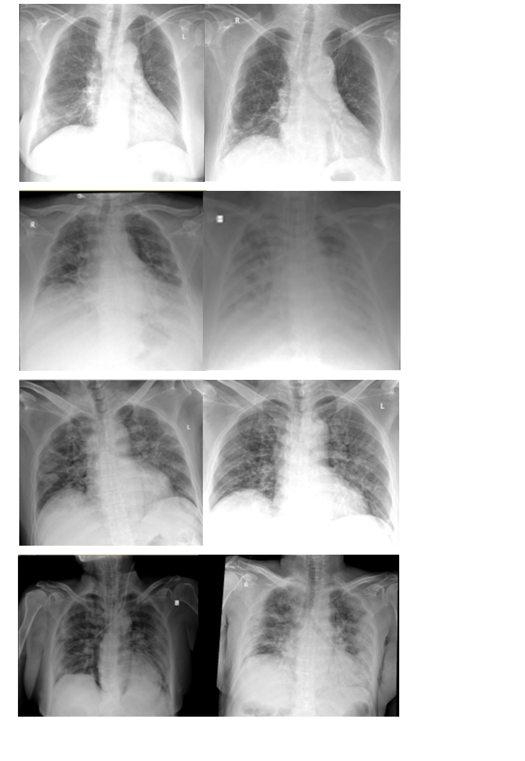

Picture 1 : Cases based on Brixia score changes. a. Low to low; b. Low to high; c. High to low; d. High to high

**Discussion**

COVID-19 has the main target in the respiratory tract which can be assessed through radiological examination, chest X-ray and lung CT-scans performed when the patient is confirmed and or suspected of COVID-19 as evidenced through rt- PCR swabs.8

The study was conducted by assessing Brixia scores on the initial chest X-ray of the treatment and follow-up photos performed during the treatment between the third and seventh days. The majority of the study samples came with a mild abnormality in chest X-ray. This is similar to the study by Sathi S, et al which reported that most (45%) hospitalized patients had a mild chest X-ray abmormality.9

The score changes judged from the two serial chest X-rays were categorized into four groups. Of the patients with mild abnormality of initial chest X-ray, only 17% (23 out of 132) experienced aggravation on serial examination. Of the patients with severe abnormality in initial chest X-ray, 84% (49 out of 58) experienced significant improvements in serial examination. This reflects a fairly good prognosis in Covid-19 patients who were hospitalized at Sumber Waras Hospital. Based on a multicenter study conducted in 15 hospitals in Jakarta, the recovery rate of COVID-19 patients treated was 85%.10

Brixia score evaluation of the length of treatment of COVID-19 patients has two conflicting opinions. In several studies that support the evaluation of Brixia scores in predicting the length of treatment.11,12 Several other studies found no correlation between changes in Brixia scores against length of treatment.13,14 Based on statistical analysis, median differences in the length treatment of that are not correlated to changes in Brixia scores can occur due to the duration from the beginning of illness or the onset of symptoms to patients entering hospitalization which may vary15, additional disease like TB and HIV15,16, the absence of standard criteria for discharge of patients from the Hospital. Patient repatriation is the full authority of the doctor in charge by considering clinical and supporting data, patients who do not have a place to self-isolate based on the Phc certificate are allowed to continue treatment at the hospital even though clinically / radiologically there are no indications of hospitalization, in the early period of the pandemic the SARS-COV2 RT-PCR examination takes a long time, so there is a possibility that stable patients have not been discharged because waiting for the result.

This study has several disadvantages, focus of the treatment length is influenced by many things, one of which is social indications where patients with mild symptoms have a long treatment duration due to the unavailability of infrastructure to self-isolate, the interval of serial chest X-ray has not been uniform because there are no operational standards and applicable procedures, the selection of times for monitoring chest X-ray is determined by the doctor the person in charge of the patient and the patient's clinical condition, there are differences in modalities in monitoring the progression of the disease, not all chest X-ray are taken, whether they are AP projections and some are PA projections with the image quality on the AP projections are not good compared to pa positions, and the presence of pre-existing comorbidity differences can obscure the findings of signs of pneumonia in COVID-19 . 17

**Conclusion**

Most of COVID-19 patients have mild symptoms with radiological findings in most pulmonary parenchyma from chest X-ray being low to low category. The median length of treatment in all Brixia score categories was 10 to 11 days and there was no significant difference in statistical tests conducted between changes in brixia scores between each category and length of treatment. The assessment of Brixia scores on chest X-ray has not been able to predict exactly the duration of treatment, the presence of severe clinical with comorbidities of the disease previously greatly affected the patient's condition in the treatment mass.

**Refference**

1. Chams N, Chams S, Badran R, et al. COVID-19: A Multidisciplinary Review. Frontiers in Public Health. 2020;8.
2. Indonesia COVID: 4,234,758 Cases and 142,952 Deaths - Worldometer [Internet]. [cited 2021 Oct 17];Available from: https://www.worldometers.info/coronavirus/country/indonesia/
3. Liu Y, Gayle AA, Wilder-Smith A, Rocklöv J. The reproductive number of COVID-19 is higher compared to SARS coronavirus. Journal of Travel Medicine [Internet] 2020 [cited 2021 Oct 17];27(2):1–4. Available from: /pmc/articles/PMC7074654/
4. Au-Yong I, Higashi Y, Giannotti E, et al. Chest Radiograph Scoring Alone or Combined with Other Risk Scores for Predicting Outcomes in COVID-19 Manuscript Type: Original Research.
5. Maroldi R, Rondi P, Agazzi GM, Ravanelli M, Borghesi A, Farina D. Which role for chest x-ray score in predicting the outcome in COVID-19 pneumonia? Available from: <https://doi.org/10.1007/s00330-020-07504-2>
6. Borghesi, A., & Maroldi, R. (2020). COVID-19 outbreak in Italy: experimental chest X-ray scoring system for quantifying and monitoring disease progression. *La Radiologia Medica*, *125*, 509–513. https://doi.org/10.1007/s11547-020-01200-3
7. Borghesi A, Maroldi R. COVID-19 outbreak in Italy: experimental chest X-ray scoring system for quantifying and monitoring disease progression. Radiologia Medica 2020;125(5):509–13.
8. Huang C, Wang Y, Li X, et al. Clinical features of patients infected with 2019 novel coronavirus in Wuhan, China. The Lancet 2020;395(10223):497–506.
9. Sathi S, Tiwari R, Verma S, et al. Role of Chest X-Ray in Coronavirus Disease and Correlation of Radiological Features with Clinical Outcomes in Indian Patients. Canadian Journal of Infectious Diseases and Medical Microbiology [Internet] 2021;2021:1–8. Available from: https://www.hindawi.com/journals/cjidmm/2021/6326947/
10. KEMENKES RI. (2021). Angka ksembuhan Covid-19. *Kementerian Kesehatan Republik Indonesia*. [www.covid19.go.id](http://www.covid19.go.id/)
11. Chiari Mattia and Gerevini AE and MR and OM and PL and SI. Length of Stay Prediction for Northern Italy COVID-19 Patients Based on Lab Tests and X-Ray Data. In: del Bimbo Alberto and Cucchiara R and SS and FGM and MT and BM and EHJ and VR, editor. Pattern Recognition. ICPR International Workshops and Challenges. Cham: Springer International Publishing; 2021. p. 212–26.
12. Kim HW, Capaccione KM, Li G, et al. The role of initial chest X-ray in triaging patients with suspected COVID-19 during the pandemic. [cited 2022 Feb 6];Available from: https://doi.org/10.1007/s10140-020-01808-y
13. Toussie D, Voutsinas N, Finkelstein M, et al. Clinical and chest radiography features determine patient outcomes in young and middle-aged adults with COVID-19. Radiology 2020;297(1):E197–206.
14. Khosravi B, Aghaghazvini L, Sorouri M, et al. Predictive value of initial CT scan for various adverse outcomes in patients with COVID-19 pneumonia. Heart and Lung 2021;50(1):13–20.
15. Soewondo, W., Putro, P. S., Hermansah, M. L., Lestari, L., Reviono, R., Harsini, H., & Adhiputri, A. (2021). Long Covid-19, Radiological Findings, and Its Management: A Systematic Review. *Indonesian Journal of Medicine*, *6*(4), 387–392. <https://doi.org/10.26911/theijmed.2021.06.04.04>
16. Soewondo, W., Kusumaningrum, C. S., Hanafi, M., Adiputri, A., & Hayuningrat, P. K. (2022). Co-existing active pulmonary tuberculosis with aspergilloma in a diabetic patient: A rare case report. *Radiology Case Reports*, *17*(4), 1136–1142. <https://doi.org/10.1016/j.radcr.2021.12.064>
17. Wang, D., Hu, B., Hu, C., Zhu, F., Liu, X., Zhang, J., Wang, B., Xiang, H., Cheng, Z., Xiong, Y., Zhao, Y., Li, Y., Wang, X., & Peng, Z. (2020). Clinical Characteristics of 138 Hospitalized Patients with 2019 Novel Coronavirus-Infected Pneumonia in Wuhan, China. *JAMA - Journal of the American Medical Association*, *323*(11), 1061–1069. https://doi.org/10.1001/jama.2020.1585