**Transcutaneous Electrical Nerve Stimulation Uptake in Lowering Low Back Pain**

**Husna Arwa Salsabil1), Hanung Prasetya2), Bhisma Murti1)**

1)Masters in Public Health, Universitas Sebelas Maret

2)Study Program of Acupuncture, Health Polytechnics, Ministry of Health Surakarta

**ABSTRACT**

**Background :** Low Back Pain (LBP) is a generalized pain from the second lumbar vertebra to the sacroiliac joint, and is generally a lifelong health disorder. LBP is often the cause of people feeling a decrease in ability in daily functional activities. Patients often complain of symptoms of pain, muscle spasms and impaired function. One of the interventions that can be used to reduce LBP is therapy using transcutaneous electrical nerve stimulation (TENS). TENS is a device used to relieve pain by stimulating nerves through electrodes transcutaneously. TENS is one of the modalities that can improve neuromuscular function or reduce pain and is very useful for patients with complaints of low back pain who experience pain and muscle weakness around the pelvis, trunk, and lower legs. LBP patient.

**Subjects and Method**: This study was a meta-analysis with the following PICO, population: low back pain patients. Intervention: administration of TENS. Comparison: not given TENS. Result: decreased pain. The articles used in this study were obtained from three databases, namely Google Scholar, Pubmed, and Science Direct. Keywords to search for articles “transcutaneous electrical nerve stimulation” OR “TENS” AND “reduction pain” OR “pain relief” AND “low back pain”. The articles included are full-text English with a randomized control trial study design from 2007 to 2022. Article selection was carried out using PRISMA flow diagrams. Articles were analyzed using the Review Manager 5.3 . application.

**Result:** A total of 12 case studies from continental Europe, America and Asia were selected for systematic review and meta-analysis. It was found that giving TENS -0.67 times reduced pain in complaints of low back pain compared to not given TENS significantly (SMD = -0.67; 95% CI = -1.03 to -0.32; p = 0.002).

**Conclusion:** Transcutaneous Electrical Nerve Stimulation reduces pain in low back pain patients.

**Keywords:** Transcutaneous Electrical Nerve Stimulation, reduction pain, low back pain

**Correspondence :**

Husna Arwa Salsabil, Masters’ Program in Public Health, Universitas Sebelas Maret. Jl. Ir. Sutami 36A, Surakarta 57126, Central Java, Indonesia. Mobile: +6289611006503. Email: husna0105@gmail.com.

**BACKGROUND**

Low Back Pain (LBP) is defined as overall pain from the second lumbar vertebra to the sacroiliac joint, and is generally a lifelong health disorder (Lee and Kang, 2016). LBP is often the cause of people feeling a decrease in ability in daily functional activities. Patients often complain of symptoms of pain, muscle spasms and impaired function.

The causes of LBP are broadly divided into two, namely non-specific and specific back pain. Non-specific low back pain is caused by strains, sprains, strains in muscles, ligaments, bearings between bones and joints which are usually caused by injury. While specific back pain is caused by herniated discs, vertebral fractures, nerve disorders, infections and tumors (Sari, 2017).

The journal The Global Burden Of Low Back Pain: Estimates From The Global Burden Of Disease 2014 Study said that of the 291 diseases studied, LBP was the largest contributor to global disability, as measured by Years Lived with Disability (YLD), and was ranked sixth of the total burden. overall, as measured by The Disability Adjusted Life Year (DALY). The prevalence of LBP in 2013 was estimated to be 9.4% higher in men with an average of 10.1% compared to women with an average of 8.7% (Hoy et al., 2014). In Indonesia, the prevalence of musculoskeletal disease based on diagnoses by health workers in Indonesia is 19% and based on diagnosis or symptoms is 24.7%. A total of 11 provinces have joint disease prevalence above the national percentage, namely Nanggroe Aceh Darussalam, West Sumatra, Bengkulu, West Java, Central Java, East Java, Bali, West Nusa Tenggara, East Nusa Tenggara, South Kalimantan, and Papua. The prevalence of musculo-skeletal disease in Central Java itself reaches 18.9% (Santoso et al., 2016).

The modalities that can be used for pain management in LBP patients can be pharmacological and non-pharmacological. Non-pharmacological modalities include exercise therapy (Fadli et al., 2021), kinesio tapping (Setiawan et al., 2021), acupuncture (Nugraha et al., 2021), aromatherapy and music therapy (Hasanah et al. , 2021), and many more. One of the modalities that can be used to reduce LBP pain is by using electrotherapy which can produce various types of electronic waves. Several evidence-based reviews of electrotherapy have found that therapy with Transcutaneous Electrical Nerve Stimulation (TENS) is beneficial for pain relief, especially in LBP patients.

Transcutaneous Electrical Nerve Stimulation (TENS) is a device used to relieve pain by stimulating nerves through electrodes transcutaneously (Patel et al., 2016). TENS is one of the safe and effective treatments for low acute and chronic LBP for more than four decades (Ahmed et al., 2012). TENS is one of the modalities that can improve neuromuscular function or reduce pain and is very useful for patients with complaints of low back pain who experience pain and muscle weakness around the pelvis, trunk, and lower legs (Shirazi and Rezaeian, 2015). In the Journal of Armed Forces Medical College written by Ahmed (2012) concluded that TENS is the right treatment to reduce pain in LBP patients effectively, safely, and more affordable.

**SUBJECTS AND METHOD**

**1. Study Design**

This research is a systematic research and meta-analysis. The articles used in this study were obtained from several databases, namely Google Scholar, Pubmed, and Science Direct between 2007 and 2021. The selection of articles was carried out using the PRISMA flow chart. The keywords to search for articles were as follows “Transcutaneous Electrical Nerve Stimulation” OR “TENS” AND “reduction pain” AND “low back pain”.

**2. Inclusion Criteria**

The inclusion criteria in this research article were: full-text article with a randomized control trial design, study subjects were low back pain patients, the results of the study were pain reduction, multivariate analysis with Standardized mean difference (Mean – SD) to measure the predicted effect..

**3. Exclusion Kriteria**

The exclusion criteria in this research article were: articles published in languages other than English, statistical results reported in the form of bivariate analysis, articles before 2007.

**4. Operational Definition of Variable**

The search for articles was carried out by considering the eligibility criteria determined using the PICO model. Population: low back pain patients. Intervention: administration of TENS. Comparison: not given TENS. Result: decreased pain.

**Transcutaneous Electrical Nerve Stimulation** is an Electro Therapy device that is used to relieve pain by stimulating nerves through electrodes transcutaneously.

**Reduction of pain** that is after the patient does therapy to relieve pain.

**5. Study Instrument**

The study was guided by the PRISMA flow chart and quality assessment using Crical Appraisal.

**6. Data analysis**

The data in the study were analyzed using the Review Manager application (RevMan 5.3). Forest plots and funnel plots were used to determine the size of the relationship and heterogeneity of the data. The fixed effects model is used for homogeneous data, while the random effects model is used for heterogeneous data across studies.

Remove duplicate articles (n= 2587)

Articles identified through database search (n= 3110)

Records excluded (n= 978)

Articles not observasional study (n=672)

Article not full text (n=307)

Filtered articles (n= 630)

Full text articles issued, with reasons (n= 4243)

1. Irrelevant title (n= 127)
2. Article not completely inclusion criteris (n=136)
3. Outcome not reduction pain (n=81)

Full text articles that are considered eligible (n= 143)

Articles included in the meta-analysis quantitative synthesis (n= 12)

**Figure 1. PRISMA *flowchart***

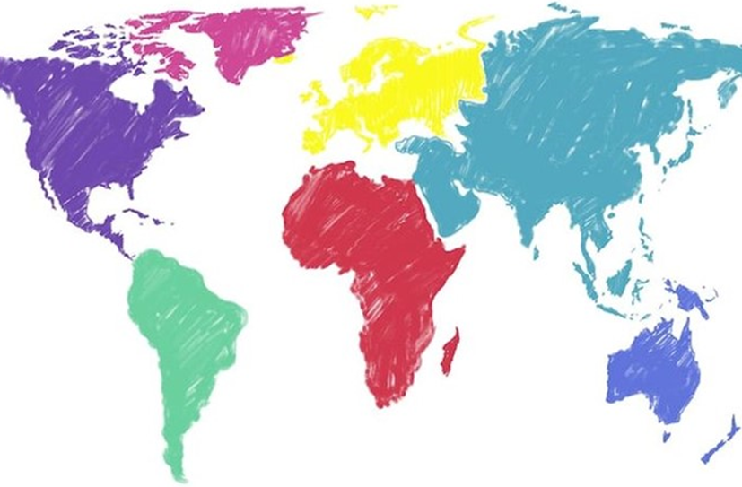

**6 research in Asia**

**3 research in Europe**

**3 research in South America**

**Figure 2. Map of the study area effect of TENS to reduction pain**

**Table 1. Description of primary studies included in the meta-analysis of TENS administration on pain reduction**

|  |  |  |  |  |  |  |  |
| --- | --- | --- | --- | --- | --- | --- | --- |
| Author (Year) | Country | Study Design | Sample | P  Population | I  Intervention | C  Comparison | O  Outcome |
| Shimoji *et al.* (2007) | Japan | RCT | 49 | Patients with chronic low back pain | TENS | No treatment | Pain reduction |
| Kofotolis *et al.* (2008) | Greece | RCT | 92 | Women aged 34-46 years with chronic low back pain. | TENS | No treatment | Pain reduction |
| Thompson *et al.* (2008) | The UK | RCT | 58 | Patients aged 20-80 years with complaints of low back pain > 1 year and < 12 years. | TENS | No treatment | Pain Reduction |
| Itoh *et al.* (2009) | Japan | RCT | 32 | Outpatients aged 60 years or older with complaints of low back pain were recruited from | TENS | No treatment | Pain Reduction |
| Alrwaily *et al.* (2019) | Brazil | RCT | 56 | Meiji University Hospital of Oriental Medicine | TENS | No treatment | Pain Reduction |
| Shirazi (2015) | Iran | RCT | 28 | Patients aged 18-60 years with complaints of low back pain more than 3 months. | TENS | No treatment | Pain Reduction |

**Table 2. Description of primary studies included in the meta-analysis of TENS administration on pain reduction**

|  |  |  |  |  |  |  |  |
| --- | --- | --- | --- | --- | --- | --- | --- |
| Author (Year) | Country | Study Design | Sample | P  Population | I  Intervention | C  Comparison | O  Outcome |
| Patel *et al.* (2016) | India | RCT | 40 | Patients aged 22-55 years with complaints of low back pain who have been examined and perform pain measurements using the SLR and VAS tests. | TENS | No treatment | Pain Reduction |
| Ahmed *et al.* (2012) | Bangladesh | RCT | 58 | Patients with complaints of acute low back pain | TENS | No treatment | Pain Reduction |
| Leemans *et al.* (2020) | Brazil | RCT | 50 | Patients with complaints of chronic low back pain who were recruited | TENS | No treatment | Pain Reduction |
| Facci *et al.* (2012) | Brazil | RCT | 150 | through posters and leaflets, distributed at the University Hospital of Brussels. | TENS | No treatment | Pain Reduction |
| Ozkaraoglu *et al.*  (2019) | Turkey | RCT | 40 | Patients with complaints of low back pain who have been diagnosed by a doctor | TENS | No treatment | Pain Reduction |
| Elserty *et al.* (2016) | Mesir | RCT | 45 | Patients aged 18-60 years with complaints of low back pain and have received a diagnosis from a doctor | TENS | No treatment | Pain Reduction |

**Table 3. Results of Quality Assessment of Randomized Control Trial Studies The Effect of TENS on Pain Reduction**

|  |  |  |  |  |  |  |  |  |  |  |  |  |  |
| --- | --- | --- | --- | --- | --- | --- | --- | --- | --- | --- | --- | --- | --- |
| **Author**  **(Tahun** | **Criteria** | | | | | | | | | | | | **Total** |
| **1** | **2** | **3** | **4** | **5** | **6** | **7** | **8** | **9** | **10** | **11** | **12** |
| **Shimoji *et al.* (2007)** | 1 | 1 | 1 | 1 | 1 | 0 | 1 | 1 | 1 | 1 | 0 | 1 | 11 |
| **Kofotolis *et al.* (2008)** | 1 | 1 | 1 | 1 | 0 | 1 | 1 | 1 | 1 | 1 | 0 | 1 | 11 |
| **Thompson *et al.* (2008)** | 1 | 1 | 1 | 1 | 0 | 1 | 1 | 1 | 1 | 1 | 0 | 1 | 11 |
| **Itoh *et al.* (2009)** | 1 | 1 | 1 | 1 | 1 | 1 | 1 | 1 | 1 | 1 | 0 | 1 | 12 |
| **Alrwaily *et al.* (2019)** | 1 | 1 | 0 | 1 | 1 | 1 | 1 | 1 | 1 | 1 | 1 | 1 | 11 |
| **Shirazi (2015)** | 1 | 1 | 1 | 1 | 0 | 1 | 1 | 1 | 1 | 1 | 0 | 1 | 11 |
| **Patel *et al.* (2016)** | 1 | 1 | 0 | 1 | 1 | 1 | 1 | 1 | 1 | 1 | 0 | 1 | 11 |
| **Ahmed *et al.* (2012)** | 1 | 1 | 1 | 1 | 0 | 0 | 1 | 1 | 1 | 1 | 0 | 1 | 10 |
| **Leemans *et al.* (2020)** | 1 | 1 | 1 | 1 | 1 | 1 | 1 | 1 | 1 | 1 | 0 | 1 | 12 |
| **Elserty *et al.* (2016)** | 1 | 1 | 1 | 1 | 0 | 1 | 1 | 1 | 1 | 1 | 0 | 1 | 11 |
| **Ozkaraoglu *et al.* (2019)** | 1 | 1 | 0 | 1 | 1 | 1 | 1 | 1 | 1 | 1 | 0 | 1 | 11 |
| **Facci *et al.* (2012)** | 1 | 1 | 1 | 1 | 0 | 1 | 1 | 1 | 1 | 1 | 1 | 1 | 10 |

Note: 1=Yes, 0=No. In question item number 11, a score of 1 is given because the question has a positive score

**RESULT**

The article search process is carried out through several journal databases, including Google Scholar, Pubmed, and Science Direct. The review process for related articles can be seen in the PRISMA flow chart in figure 1. Research related to the administration of TENS on pain reduction consisted of 12 articles from the initial search process yielding 3,110 articles, after the deletion process was published articles with 143 requirements for further full-text review. A total of 12 articles that met the quality assessment were included in the quantitative synthesis using a meta-analysis. It can be seen in Figure 2 that the research articles come from three continents, namely Europe (Turkey, England, and Greece), Asia (Japan, Egypt, India, Bangladesh, and Iran) and South America (Brazil). Table 2, researchers conducted an assessment of the quality of the study using critical appraisal tools randomized controlled trial (RCT) published by CEBM University Of Oxford 2014:

1. Does the research address clearly focused statements/problems?
2. Is the Randomized Controlled Trial research method appropriate to answer the research question?
3. Are there enough subjects in the study to establish that the findings did not occur by chance?
4. Were subjects randomly allocated to the experimental and control groups? If not, could this be biased?
5. Are inclusion/exclusion criteria used?
6. Were the two groups comparable at the start of the study?
7. Were objective and unbiased outcome criteria used?
8. Are objective and validated measurement methods used in measuring the results? If not, were results assessed by someone who was not aware of the group assignment (ie was the assessment blinded)?
9. Is effect size practically relevant?
10. How precise is the estimate of the effect? Is there a confidence interval?
11. Could there be confounding factors that have not been taken into account?
12. Are the results applicable to your research?

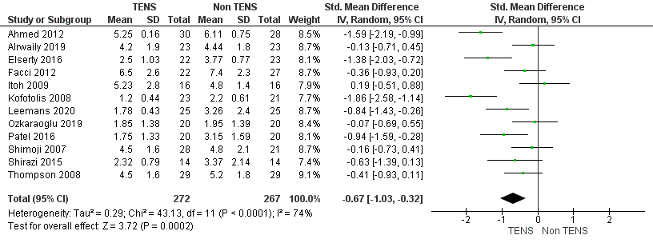

**Figure 3. Forest Plot Effect of TENS on Pain Reduction**

1. **Forest Plot**

Based on the results of the forest plot (Figure 3), it shows that giving TENS can reduce pain. The results of a meta-analysis in a randomized controlled trial study showed that giving TENS can reduce pain as much as -0.90 times in reducing pain in patients with low back pain compared to those without TENS and the results were statistically significant (SMD = -0.67; 95% CI = -1.03 to - 0.32; p=0.0002). The heterogeneity of the research data shows I2 = 74% so that the distribution of the data is declared heterogeneous (random effect model).

1. **Funnel Plot**

Based on Figure 4. it shows that there is a publication bias which is indicated by the asymmetry of the right and left plots where 6 plots are on the right and 5 plots are on the left, and 1 plot is attached to a vertical line. The plot on the right of the graph appears to have a standard error (SE) between 0.2 and 0.4. The plot on the left of the graph appears to have a standard error (SE) between 0.3 and 0.4. Bias also occurs from the imbalance between the distances between studies on both the right and left sides of the funnel plot.

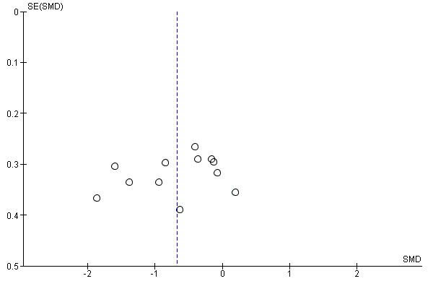

**Figure 4. Funnel Plot Effect of TENS on Pain Reduction**

**DISCUSSION**

This research is a systematic research and meta-analysis that raises the theme of the effect of giving TENS on pain reduction. This systematic study and meta-analysis used controlled research for confounding factors that could be seen from the inclusion requirements of the study, namely multivariate analysis, and statistical results reported with Standardized mean difference (Mean – SD). Estimates of giving TENS to pain reduction were processed using RevMan 5.3 with the generic inverse variance method.

The results of the systematic study and meta-analysis are presented in the form of forest plots and funnel plots. The forest plot provides an informational overview of each study examined in the meta-analysis, and an estimate of the overall outcome (Murti, 2018). The funnel plot shows visually the amount of variation (heterogeneity) (Akobeng, 2005 in Murti, 2018). Funnel plots show the relationship between study effect sizes and the sample sizes of the various studies studied, which can be measured in a number of different ways.

The primary studies that met the criteria regarding the effect of giving TENS on pain reduction were 12 articles from 3 European continents, 3 from South America, and 6 from Asia. This study shows that giving TENS can reduce pain as much as -0.67 times reducing pain in patients with low back pain than without TENS and the results are statistically significant (SMD = -0.67; 95% CI = -1.03 to -0.32; p = 0.0002) . The heterogeneity of the research data shows I2 = 74% so that the distribution of the data is declared heterogeneous (random effect model). Low back pain is pain that is limited to the lumbar region, but the symptoms are more uniform and are not limited to one nerve root, but widely originate from the lumbar intervertebral disc (Nurdiati et al., 2015). The main categories of suspected risk factors for LBP are individual and activity-related factors. There have been several reviews questioning whether changes in behavioral variables and reduced disability that facilitate improved function may be more important than physical performance factors for successful treatment of chronic low back pain (Delitto et al., 2012).

Research conducted by Leemans et al. (2020) stated that giving active TENS can reduce pain, including during functional activities and reduce the use of analgesic and anti-inflammatory drugs. TENS can modify not only the nociceptive component of lumbar pain, but also the neuropathic component. Because the treatment protocol consisted of a combined program of conventional TENS (Gate Control) and like acupuncture, improvement in lumbar pain could not be attributed to TENS like acupuncture alone.

This study is in line with Shirazi and Rezaeian (2015) stating that the application of TENS to LBP showed a statistically significant improvement in pain reduction and postural control in the medio-lateral direction without a corresponding effect in the anterior-posterior direction. Low-frequency TENS with level amplitude contractions appears to have a positive effect on postural control in chronic LBP patients. Therefore, this study demonstrated the efficacy of low-frequency TENS in improving postural control in patients with chronic LBP.

Ahmed et al. (2012) stated in his journal that the results obtained in this study TENS is an appropriate intervention for acute LBP. From this study it was concluded that the administration of TENS in patients with LBP was very beneficial. TENS is an appropriate intervention for acute LBP, safer or more effective in other ways. From this study it may be concluded that the effect of TENS in patients with LBP is beneficial. Particular attention should be paid to the risks and benefits of long-term use, which more precisely addresses the realities of managing acute LBP.

**AUTHOR CONTRIBUTION**

Husna Arwa Salsabil is the main researcher who chooses the topic, explores and collects data. Hanung Prasetya and Bhisma Murti played a role in analyzing data and reviewing research documents.

**CONFLICT OF INTEREST**

There is no conflict of interest in this study.

**FUNDIND AND SPONSORSHIP**

This research is self-funded.

**ACKNOWLEDGEMENT**

We are very grateful to the database providers PubMed, Google Scholar and Science Direct.

**REFERENCES**

Adhiyoga Santosa, I Putu Eka Widyadharma, T. E. P. 1. (2016). *Korelasi Lama Duduk Dengan Nyeri Punggung Bawah Pada Pekerja Hotel The Grand Santhi Denpasar (The Correlation of Sitting Length With Lower Back Pain In The Grand Santhi Denpasar Hotel Workers)*. *5*(10), 1–5.

Ahmed B, Alam S, Rashid I, Rahman N, Rahman A, Uddin T, & Azad G. (2012). Effects Of Transcutaneous Electrical Nerve Stimulation (Tens) On Patients With Acute Low Back Pain. *Armed Forces Med J, Bangladesh*, *7*(2), 29–32. <https://doi.org/10.3329/jafmc.v7i2.10393>

Alrwaily M, Schneider M, Sowa G, Timko M, Whitney S L, & Delitto A. (2019). Stabilization Exercises Combined With Neuromuscular Electrical Stimulation For Patients With Chronic Low Back Pain: A Randomized Controlled Trial. *Braz J Phys Ther.*, *23*(6), 506–515. <https://doi.org/10.1016/j.bjpt.2018.10.003>

Delitto A, George S Z, Dillen L Van, Whitman J M, Sowa G, Shekelle P, Denninger T R, & Godges J J. (2012). Low Back Pain Clinical Practice Guidelines Linked to the International Classification of Functioning, Disability, and Health from the Orthopaedic Section of the American Physical Therapy Association. *Journal of Orthopaedic and Sports Physical Therapy*, *42*(6), 573. <https://doi.org/10.2519/jospt.2012.0301>

Elserty N, Kattabei O, & Elhafez H. (2016). Effect Of Fixed Versus Adjusted Transcutaneous Electrical Nerve Stimulation Amplitude On Chronic Mechanical Low Back Pain. *J Altern Complement Med*, *22*(7), 557–562. https://doi.org/ 10.1089/acm.2015.0063

Facci L M, Nowotny J P, Tormem F, & Trevisani V F M. (2011). Effects Of Transcutaneous Electrical Nerve Stimulation (TENS) And Interferential Currents (IFC) In Patients With Nonspecific Chronic Low Back Pain: Randomized Clinical Trial. *Sao Paulo Med. J*, *129*(4), 206–216.

Itoh K, Itoh S, Katsumi Y, & Kitakoji H. (2009). A Pilot Study On Using Acupuncture And Transcutaneous Electrical Nerve Stimulation To Treat Chronic Non-Specific Low Back Pain. *Complementary Therapies in Clinical Practice*, *15*(1), 22–25. <https://doi.org/10.1016/j.ctcp.2008.09.003>

Kofotolis N D, Vlachopoulos S P, & Kellis E. (2008). Sequentially Allocated Clinical Trial Of Rhythmic Stabilization Exercises And TENS In Women With Chronic Low Back Pain. *Clinical Rehabilitation*, *22*(2), 99–111. https://doi.org/10.1177/ 0269215507080122

Leemans L, Elma Ö, Nijs J, Wideman T H, Siffain C den, Bandt H, Van Laere S, & Beckwée, D. (2021). Transcutaneous Electrical Nerve Stimulation And Heat To Reduce Pain In A Chronic Low Back Pain Population: A Randomized Controlled Clinical Trial. *Braz J Phys Ther.*, *25*(1), 86–96. [https://doi.org/10.1016/j.bjp t.2020.04.001](https://doi.org/10.1016/j.bjp%20t.2020.04.001)

Murti, B. (2018). *Prinsip dan Metode Riset Epidemiologi (5th ed.) (Principles and Methods of Epidemiological Research (5th ed.)).* Program Studi Ilmu Kesehatan Masyarakat, Program Pascasarjana, Universitas Sebelas Maret.

Ozkaraoglu D K, Tarakci D, & Algun Z C. (2020). Comparison Of Two Different Electrotherapy Methods In Low Back Pain Treatment. *J Back Musculoskelet Rehabil*, *33*(2), 193–199. <https://doi.org/10.3233/BMR-181199>

Patel J I, N P K B, & N D R V. (2016). Effect Of Mckenzie Method With Tens On Lumbar Radiculopathy-A Randomized Controlled Trial. *Int. J. Physiother.*, *3*(1), 94–99. <https://doi.org/10.15621/ijphy/2016/v3i1/88919>

Rojhani Shirazi Z, & Rezaeian T. (2015). The Effects Of Transcutaneous Electrical Nerve Stimulation On Postural Control In Patients With Chronic Low Back Pain. *J Med Life*, *8*(2), 19–27. ­ http://www.ncbi.nlm.nih.gov/pubmed/28255392%0A <http://www.pubmedcentral.nih.gov/articlerender.fcgi?artid=PMC5327705>

Santoso T B, & Fitriyani W. (2013). *Efektifitas dan kenyamanan transcutaneus electrical nerve stimulation (TENS) pulse burst dan arus trabert dalam mengurangi nyeri kronik di lutut pada usia lanjut (Effectiveness and convenience of transcutaneous electrical nerve stimulation (TENS) pulse burst and trabert current in reducing chronic knee pain in the elderly)*. <https://publikasiilmiah.ums.ac.id/xmlui/handle/11617/3319>

Shimoji K, Takahashi N, Nishio Y, Koyanagi M, & Aida S. (2007). Pain Relief By Transcutaneous Electric Nerve Stimulation With Bidirectional Modulated Sine Waves In Patients With Chronic Back Pain: A Randomized, Double-Blind, Sham-Controlled Study. *Neuromodulation*, *10*(1), 42–51. [https://doi.org/10.1111/j.15 25-1403.2007.00086.x](https://doi.org/10.1111/j.15%2025-1403.2007.00086.x)